|  |  |
| --- | --- |
|  | Software Development Plan |
| 5/7/2013 | Graduate Capstone |

Table of Contents

1 Introduction 2

1.1 Indented Audience 2

1.2 References 2

1.3 Revision History 2

2 Defining Project Artifacts and Deliverables 3

2.1 Vision and Scope Document 4

2.2 Software Requirement Specification 4

2.3 Architectural and Detailed Design Documents 4

2.4 Source and Executable Code 4

2.5 Test Plan 4

2.5.1 Web Services 4

2.5.2 Integration 4

2.6 Acceptance Plan 5

2.7 Periodic Reporting 5

2.8 Deployment Plan 6

2.8.1 Stage One 6

2.8.2 Listing on App Marketplaces 6

2.8.3 Marketing 6

2.8.4 Future Releases 6

2.9 User and Operational Manuals 6

2.10 Risk Management Plan 7

2.11 Work Breakdown Structure 7

2.12 Test Plan 7

3 Software Development Process Model 7

3.1 Software Process Model 7

3.1.1 Unified Process Model 8

3.1.2 Waterfall Model 8

3.1.3 Iterative Model 8

4 Defect Prevention Process 9

4.1 Defect Methodology 9

4.2 Defect Reporting 9

5 Change Management Plan 10

6 Project Effort 10

7 Project Schedule 10

8 Developer Log 10

9 Documentation Formatting 11

10 Reflection Document (CSC650) 12

# 1 Introduction

This purpose of this document is to identify all documentation and resources used in the entire project and where to each artifact can be found. It is geared to be used as a resource as well as a learning tool for those new to the project.

## 1.1 Indented Audience

This document is intended for anyone of all technical and business backgrounds. Also this is geared for anyone of any understanding of the project.

## 1.2 References

* <http://www.enterim.com/docs/Example%20Software%20Development%20Plan.pdf>
* <http://sce.uhcl.edu/helm/rationalunifiedprocess/process/artifact/ovu_arts.htm>

## 1.3 Revision History

|  |  |  |  |
| --- | --- | --- | --- |
| Name | Date | Reason For Change | Version |
| Andy Bottom | 04/29/2013 | Started compiling the plan into the document | 0.1 |
| Andy Bottom | 05/07/2013 | Finished the finalizing of the first version. Wrote the reflection paper as well. | 1.0 |

# 2 Defining Project Artifacts and Deliverables

Below is a list of the flow of artifacts between one another.

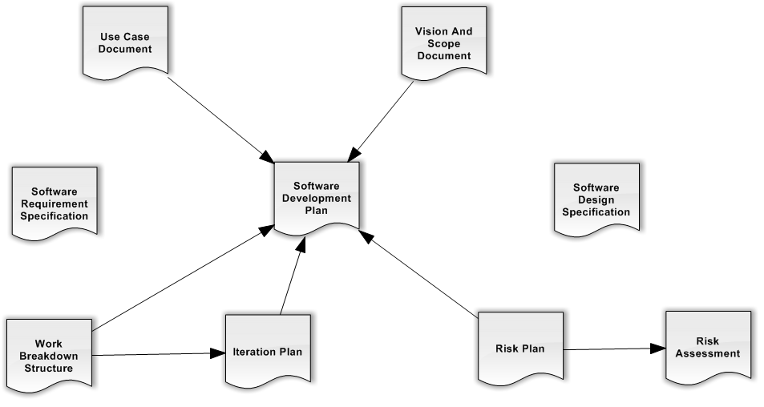

## 2.1 Vision and Scope Document

@SEE Vision and Scope Document

## 2.2 Software Requirement Specification

@SEE SRS

## 2.3 Architectural and Detailed Design Documents

@SEE Use Case Document

@SEE The Database Design Document for further analysis of the Data and Database Design.

## 2.4 Source and Executable Code

NOTE: Will be delivered upon request in digital format.

## 2.5 Test Plan

Testing for the application has no separate entity to test. Technical Testing will be performed by Andy Bottom. Requirement Verification will be performed by Andy Bottom. Testing will be performed as the product is be develop

### 2.5.1 Web Services

The web services and the Data Access Layer reside in the web services are the most important area as it contains most of the logic in the system. Thus this will be an area where automated testing would be performed. We will use SoapUI to create tests for the data. Unfortunately load testing is outside the scope of this project.

### 2.5.2 Integration

After large pieces of functionality are performed, integration with the other parts of the software will be done to ensure no other extraneous bugs occur.

## 2.6 Acceptance Plan

The acceptance testing of the phone application will be performed by Andy Bottom and also by friends of Andy Bottom. The acceptance testing for the Administrator Web Application will be performed by Andy Bottom and a couple of Andy Bottom’s Friends.

The test environment will be on several mobile phone operating systems and also through the web browsers.

## 2.7 Periodic Reporting

Updates to documents and reporting will be done on a reoccurring basis. Changes to any of the documentation will be logged in the revision section of the corresponding document.

|  |  |  |
| --- | --- | --- |
| Document | Action | Schedule |
| Software Requirement Specification | Updates and changes | Bi-Weekly |
| Software Development Plan | Updates and Changes | Bi-Weekly |
| Vision and Scope Document | Updates and Changes | Bi-Weekly |
| Use Cases | Additions; Updates; | Weekly |
| Functional Requirements | Updates or Changes | Weekly |
| Code | Backup | Weekly |
| Database | Backup | Monthly |
| Test Cases | Additions; Updates; | Weekly |
| Defect Tracking | Additions; Updates; | Daily |

## 2.8 Deployment Plan

### 2.8.1 Stage One

* Reading of Hardware, Database and Data
* At this stage, all testing should have been completed and successful.
* Data in the Database must be cleaned up and started fresh. This is so that all the data generated during development and testing will be removed.

### 2.8.2 Listing on App Marketplaces

Microsoft, Android and iOS all have their own marketplaces. Each marketplace has fee in order to list on there.

* All Licenses must be purchased to have the application listed on the stores
* Developer profile must be created
* Application must be sent to be submitted on the marketplace
* In addition, screenshots, descriptions, features and icon must be created to help market the application once it is listed.

### 2.8.3 Marketing

* Promotional material will be created to promote the application

### 2.8.4 Future Releases

Updates will be released to ensure the application remains successful

* Bug Fixes
* Feature Updates

## 2.9 User and Operational Manuals

@TODO: This document will be created during the Transition Phase

## 2.10 Risk Management Plan

@ See Risk Management Plan

## 2.11 Work Breakdown Structure

@SEE Work Breakdown Structure Document

## 2.12 Test Plan

The testing of the code will be done during the Construction and Transition phases. All code will be tested during development. After a requirement is completed coding, it will be tested to be verified that the requirement has been fulfilled by using the FIT Criteria found on the requirement. In addition, after a development iteration has been completed. An entire smoke test will be done on the entire system again to ensure no integration problems have occurred.

In addition to the manual testing, hopes of automated tests will be created to easy general testing of the system. Although the automated tests will be outside the scope of the project at the moment, but in the future may be a possibility.

# 3 Software Development Process Model

## 3.1 Software Process Model

Analysis of which process model will be followed during the project is a very important aspect. One major disadvantage in this project is that I am the one man team in this entire project. With this, I really can only focus on one aspect of the project at once. In contrast, most processes are followed with the assumption that there are many people involved so that several areas of the project can be concurrently worked on and focused. Since I will be working on this solo, the following a Unified Process is very difficult. But nevertheless, a process must be chosen to follow.

### 3.1.1 Unified Process Model

I will be following a mix of models during the implementation. First off, I will be including the four major stages of the Unified Process (UP) Model. This process will contain the following categories.

* Inception Phase
* Elaboration Phase
* Construction Phase
* Transition Phase

### 3.1.2 Waterfall Model

I understand that the waterfall model is very old-fashioned and non-robust to changes. However, since there is no outside client for the moment, requirement and other aspects of the project aren’t anticipated to be changed. Also, the waterfall model follows a very narrow minded focus of working on one area at a time. This works will since I will be the only individual working on the project, so the single focused trait works well in this instance.

### 3.1.3 Iterative Model

Even though the overall workflow of the project will be single focused, I intend to break up parts of the process into iterative cycles when possible. Since there are several domains in the system, cycles to complete each domain, (requirement and development) will be done. Also, once the basic framework of the entire system is implemented and functioning, then an iterative model will be followed more thoroughly by breaking up selected features and implement them and cycle through again until all desired features of the system are implemented and tested. At this point the transition phase would be done to end the project.

# 4 Defect Prevention Process

## 4.1 Defect Methodology

Defects will be found during development and testing. The ability to find these defects is vital to the success of the project to mitigate as many defects as possible. It is the goal to implant a defect mitigation mindset to help improve the quality of the code base and develop functionality that fulfills as closely specified by the requirements.

## 4.2 Defect Reporting

The success of addressing all defects is defined by the ability to track and log all defects found in the system. All automated reporting will create a log when ran to identify all failed tests. The logs would then be able to identify potential defects.

Also, a heavy presence of user testing will be needed to identify defects on all platforms and systems. A log will be created to catch any errors that occur. These logs will then be able to identify potential defects. Also, User Acceptance Testers will be able to fill out a defect card to track the bug.

Most bugs are hoped to be identified during the implementation phase. Whenever bugs are found that are unrelated to the current functionality found, a defect card will be created, identify the bug and other useful information, and then the bug will be put into the work backlog. The defects will then be fixed at the next available development time, in order of priority of the defect.

@TODO: List of Defects will be created during the Construction Phase

# 5 Change Management Plan

All changes to all documentation, diagrams, and code artifacts will be managed in the documents themselves. In each document there is a revised history table which displays the all the major changes that have occurred in the document. By doing this, we can preserve and identify when the last modification occurred and result in a through and up-to-date project specifications.

# 6 Project Effort

For this project, the use of effort points as a form of measurement to any given task will not be used in this project. The reason is because since there is only one person working on it, that the points will not have an impact on what gets done. Requirements will be worked on based on the system and related system it is in. Points will not determine when a requirement will get worked on. Also, due to the fact that there is a short time constraint on the development aspect of the project, and the learning curve it takes to accurately assign effort points will also pretty much render the task null and void. However, we recognize the usefulness the effort pointing provides, thus in future iterations where there would be a more team environment to accomplish tasks, the use of effort points may be reconsidered.

# 7 Project Schedule

@SEE Iteration Plan

# 8 Developer Log

@SEE Iteration Plan

# 9 Documentation Formatting

All text will be spaced with 1.5 spacing to allow for additional comments and revisions marks to be easily written on the document itself.

Spacing in tables will be 1.5 spaced. However based on the context that the table is located, the spacing may be single spaced to allow for a cleaner transition between pages.

Another note that the table of contents will be single spaced.

Headings and Subheadings will follow the standard technical software documentation by beginning with numbers and decimals.

Each document will contain very helpful links describing documentation which I felt were great resources about how to organize my documentation.

Each page will have a cover page and table of contents.

General text size of the body will be 11 point font.

# 10 Reflection Document (CSC650)

I’d like to start about reflecting back to my undergraduate Capstone which I did two years ago. It is truly remarkable of how much one can learn in just that short amount of time. Within that, I have taken many Graduate Classes where I gained a greater understanding of the entire software development life cycle. In addition to this I also gained almost two years of internship and work experience as a developer. I learned how to interact with everyone involved and so how the software development process worked in the “real world.”

I truly feel that I have a very deep understanding of the software development process and can see how it is approached from different point of view including business, developer, tester, user experience developer and from the user. It is all these points of views and my experience that I brought to the table this time around when I was to work on my capstone project.

I must say that I did quite a lot of research and time on this project. The ability to run and develop my own project and product in a more professional manner was a very great opportunity. The product is on a great projection and hopefully will prove to be successful and useful to myself and others.

The hardest part of this project is easily the fact that I am essentially the only person involved with the entire product. This is evident when the usual needs that occur in software development arise as I am the one who has to do it all. This then leads to some things being put off and other things taking focus.

If I had to make a change, I would have liked to have spent the upfront time to develop my documentation a little bit earlier as it may have been easier to track changes and promote better habit of documenting, if I had a system already in place. But overall, my effort in this project has been no less than 100% and I am very proud of all that I have accomplished in it. I look forward to seeing the product come together during the summer.